INSTRUCTIONS FOR TAKING BLOOD SAMPLES FOR MONITORING PKU
Timing of Sample
It is important to take the sample first thing in the morning before you have anything to eat or take your PKU supplements.
To take a sample you will require:
- Lancet
- Blood spot card or blood bottle
- Cotton Wool to stop bleeding
- Laboratory request form if using blood bottles
- Labels with your name and address details
- Envelope addressed to Blood Sciences RVI for cards or sample box for tubes
The samples can be taken into blood tubes or onto bloodspot cards according to what you have been told to use at the PKU clinic.
Taking the sample:
- Wash your hands using hot water and soap and dry thoroughly
- Place the lancet on the side of your fingertip and press the release button
- Hold your hand so the fingers are facing downwards and let a drop of blood form
- You might need to squeeze your finger lightly by pressing and releasing from the base towards the fingertip to get the blood to flow. Do not squeeze too hard or the sample will not be suitable for the lab to measure

How to Collect onto Blood spot Cards:
You only need to fill one circle but make sure that the blood soaks right through to the other side (see pictures at end of sheet for examples of good and bad cards)
Hold your finger over the blood spot card and let the drop of blood fall onto the circle
Allow the card to dry for 15 -20 minutes before putting it into the glassine sleeve and then place inside the envelope addressed to the lab.
Attach a first class stamp
The sample must be posted the same day to ensure that it arrives at the lab the next day.

How to Collect Into blood bottles:
Touch the blood droplet to the side of the blood bottle and the blood will run into the tube
Wait for a second drop to form and repeat
Close the bottle with the provided lid, making sure it is tight
Place a name sticky label around the bottle and then place the bottle into the plastic bag attached to the back of the laboratory form.
Place sample into transport box and seal with the security tag
Label box with the laboratory address (found at the end of the information sheet)
These must have a LARGE Letter first class stamp attached for posting

Completing the Blood Form or Card
Complete the blood form by placing your sticky labels on all pages, include the date you take the sample and “PKU monitoring” in the clinical details as shown below.
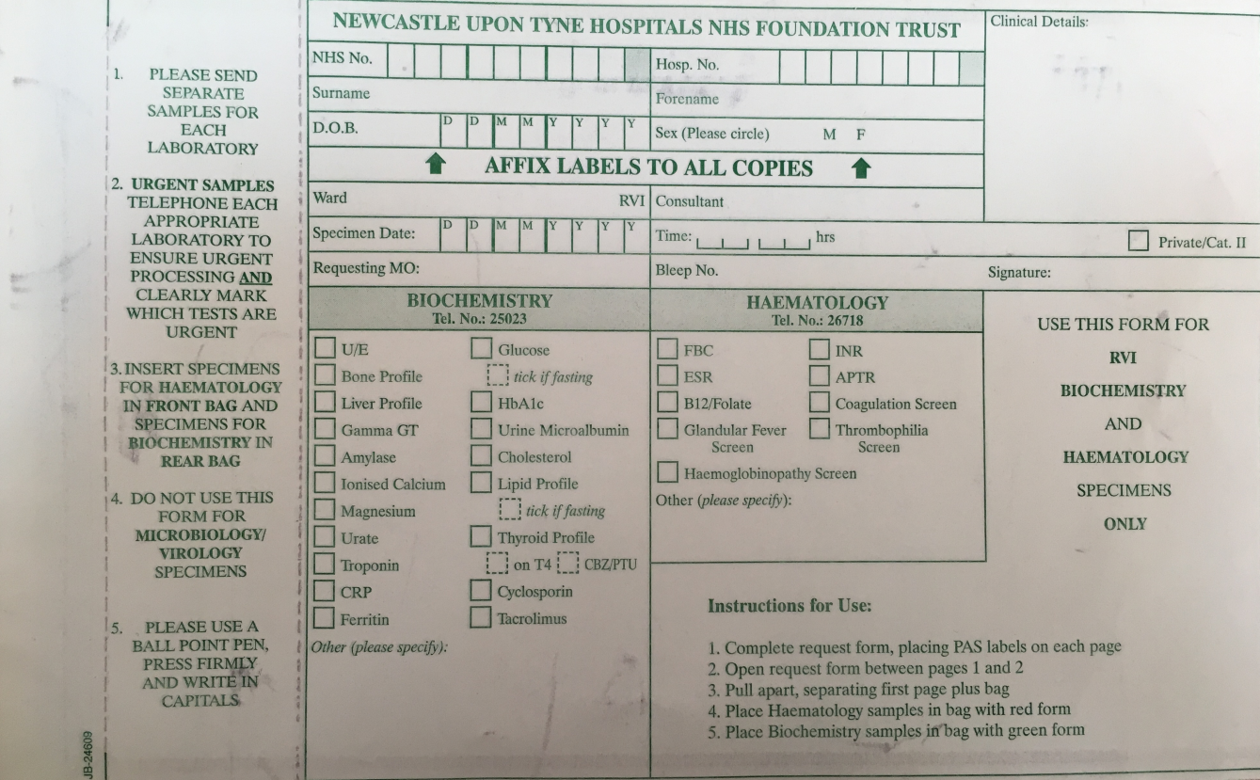
Phenylalanine
PKU for monitoring
Put your name sticky label here
Remember and write in the date you take the sample here

If using a bloodspot card, place sticky labels on all pages and write “PKU monitoring” and the date on the card.
Put the date you take the sample here

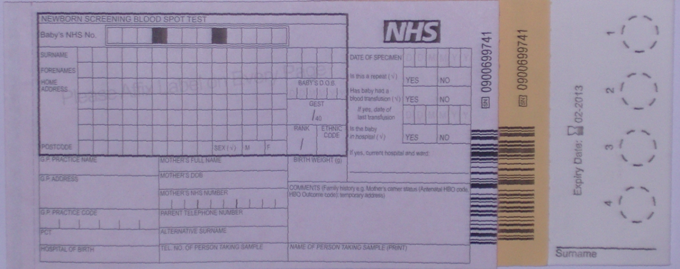
Put your name and address sticky label here.
PKU Monitoring

Please address all samples as follows:
Department of Blood Sciences
Royal Victoria Infirmary
Queen Victoria Road
Newcastle upon Tyne
NE1 4LP

Further Supplies
If you need any further supplies of tubes/cards/boxes or labels please contact us on 0191 2824301 and we will arrange for them to be sent out to you or they can be collected when you come to an outpatient clinic appointment.

Results
You will be contacted by the clinic dietician with the results of the blood test when it is available. Please ensure that you have provided up to date contact details.

Example Cards
- A single spot needs to be placed in a circle. Multiple spots together give inaccurate results and will not be accepted by the lab.
- The bloodspot needs to fill the whole circle, if it is too small, it will under estimate the Phenylalanine and will be rejected by the lab.
- This is perfect, the blood fills the whole circle and has soaked right through to the back of the card.
2
3
1

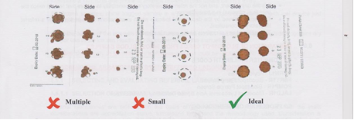

PLEASE REMEMBER YOU ONLY NEED TO FILL ONE SPOT FOR PKU MONITORING

